List of File changed in VM
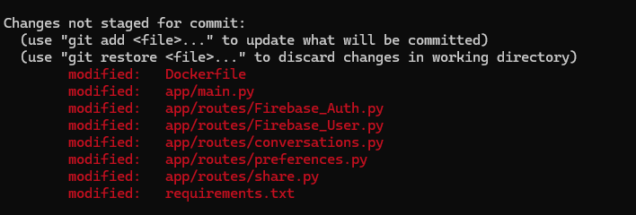

Changes Snapshots

- Dockerfile

CMD ["uvicorn", "app.main:app","--host", "0.0.0.0", "--port", "8000",
"--ssl-certfile=/app/app/fullchain.pem",
"--ssl-keyfile=/app/app/privkey.pem"]

- Main.py

Add domain name in CORS

app.add_middleware(
CORSMiddleware,
allow_origins=[
"http://127.0.0.1:8000",
"http://127.0.0.1:8003",
"http://127.0.0.1:5500",
"http://localhost:5500",
"http://localhost",
"http://localhost:5173",
"http://curie.healthark.ai:5173",
"https://curie.healthark.ai:5173",
"https://curie.healthark.ai:8003",
"http://curie.healthark.ai:8003",
"http://4.224.156.184:5173",
"https://curie-frontend.vercel.app",
],
allow_credentials=True,
allow_methods=["*"],
allow_headers=["*"],
)

Change the prefix Section in Share Chat router Remove it

app.include_router(share.router, tags=["Share"])

- FIrebaseAuth ,FirebaseUser ,preferences and Convertation router in /app/routes

Change the router
router = APIRouter(prefix="/api/auth", tags=["Auth"])
and add prefix as /api

- In share.py

Change the router as /api/share

- Requirements.txt

I didn’t do anything here

